Chapter 11, Problem 95.

A coupling capacitor is used to block dc current from an amplifier as shown in Fig. 11.98(a). The amplifier and the capacitor act as the source, while the speaker is the load as in Fig. 11.98(b).

- At what frequency is maximum power transferred to the speaker?

- If V_{s} = 4.6 V rms, how much power is delivered to the speaker at that frequency?

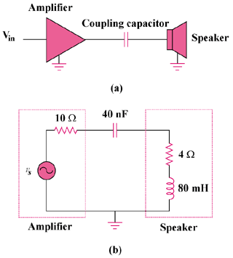

Figure 11.98
For Prob. 11.95.

